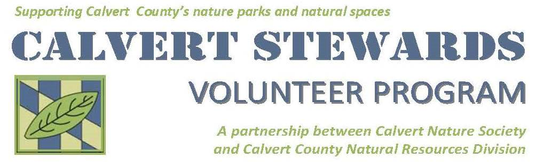

2880 Grays Rd. Prince Frederick MD, 20678

410-535-5327

<https://calvertstewards.galaxydigital.com/>

Hello Calvert Stewards!

For the last half of the year, July – December we had 2,866.97 hours logged and a total of 65 volunteers.

We thank our volunteers for all their hard work this year. We can’t do it without you all. We have multiple upcoming opportunities that we need your help with! For upcoming activities in the Winter, we have opportunities in Park Maintenance, Winter Raptor Research, and iNaturalist Projects . Please check out our site if you are interested. <https://calvertstewards.galaxydigital.com/need/>

Paige Stevens & Kevin Creek

Nature Center Aides

[Paige.stevens@calvertcountymd.gov](mailto:Paige.stevens@calvertcountymd.gov), Kevin.creek@calvertcountymd.gov

Volunteers in Action July-December 2022

Top Row: Mary Hollinger with Wildlife Rescue Transport Team. Jason Avery watching Gene Groshon band a Saw-whet Owl. Scott Clark & Joe Clark at M.A.P.S

Middle Row: Bluebird Trail Installation, Rick Popp, Mary Hollinger, Maggie Silverman, Tonya Stanley, Kathleen Smith, Shelly and John Posey, August Rowell, Ian Keeley and Braedyn McIntosh. Camp Training, Lauren Kleist, Sekai Manley, Oliver Diamond, and Caroline Wingate.

Bottom Row: Penny Moran teaching CHESPAX Oysters. Eagle Scouts Troop 407 build new sign for Battle Creek Cypress Swamp, Joshua Jenkins, Blaze Spencer, Seth Dodson, Jeremiah Jenkins, Noah Jenkins, Phillip Jenkins, Patrick Surfus, Mason Hood

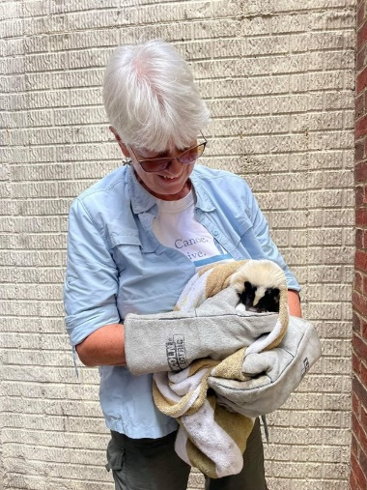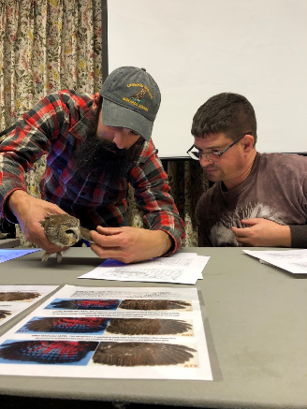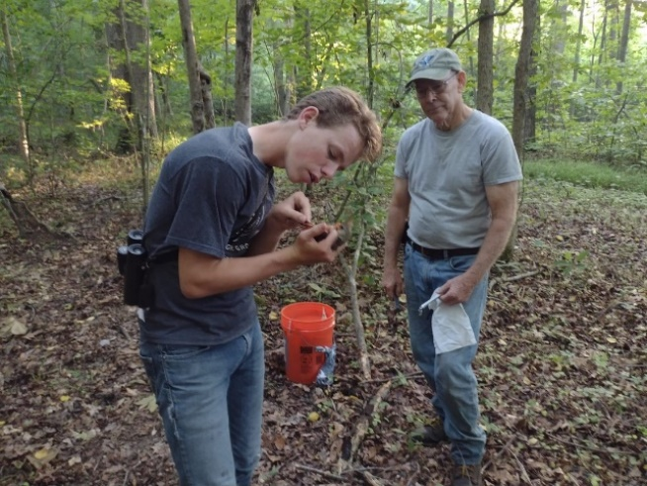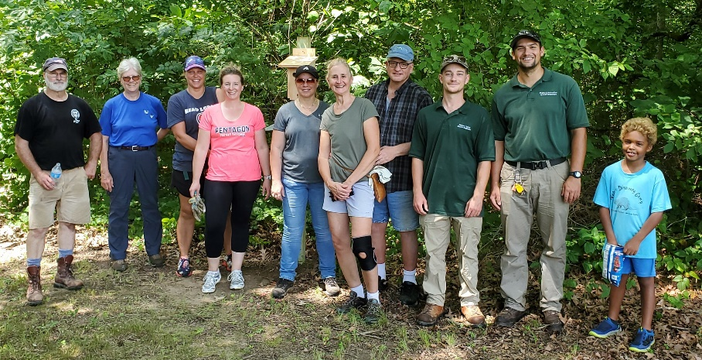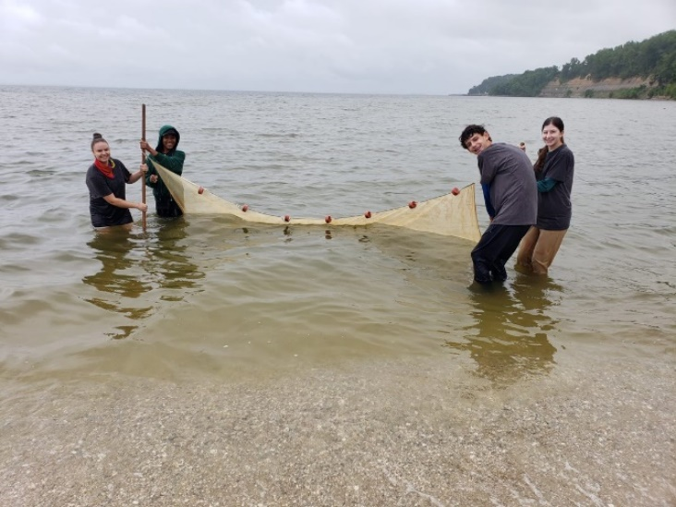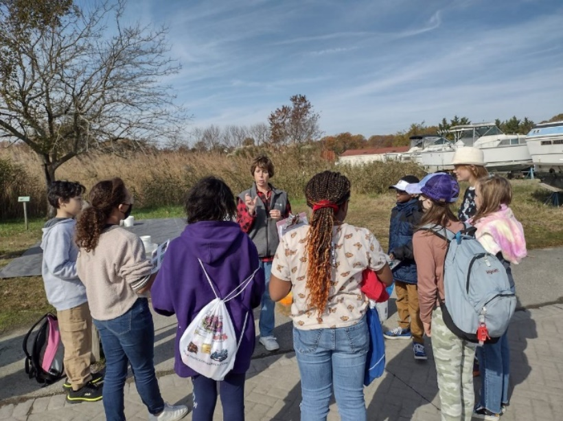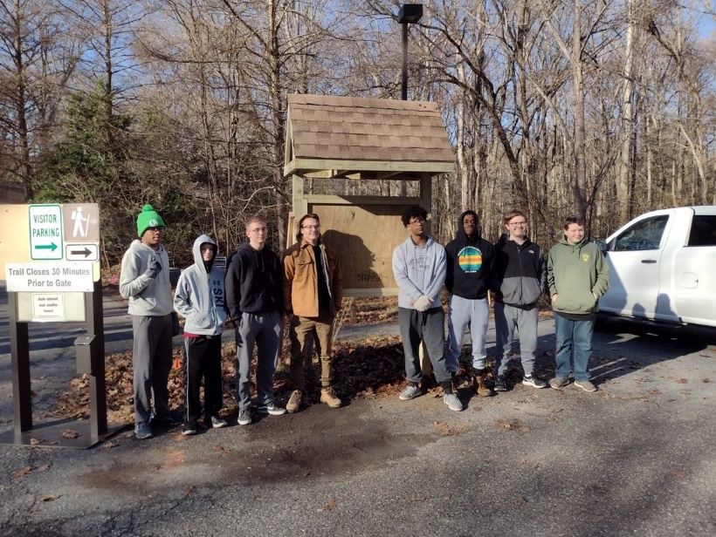

Volunteer recognition and appreciation:

CHESPAX Oysters end of season lunch with Liz Orlandi, Mike Shisler, Fred Bumgarner, and Laurie Snow. Maggie Silverman at Point Lookout Monarch Tagging.

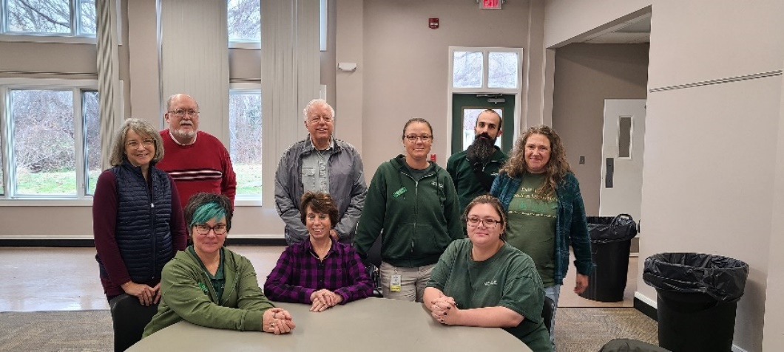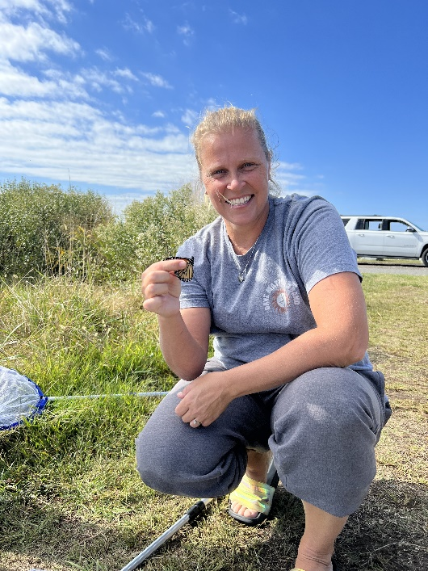

Photos from Calvert Stewards while volunteering for different projects: Wood duck eggs from Battle Creek Cypress Swamp Nest box monitoring, Monarch caterpillar from Monarch larvae Monitoring, Saw-whet Owl from Saw-whet Project.

